Maps of the Area Mesh Units surrounding the Parks we studied - 2016

Ormiston – Barry Curtis Park

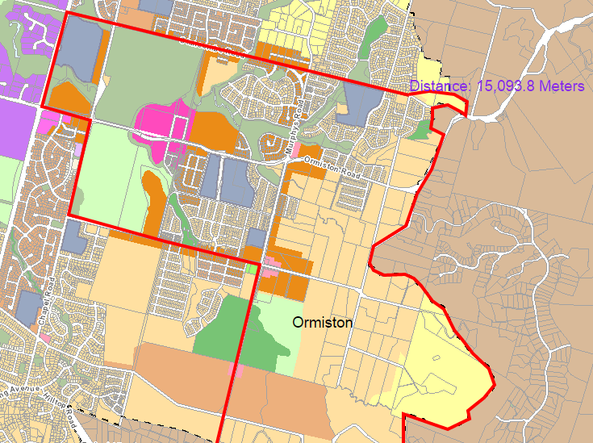

Onehunga South East – Jordan Park

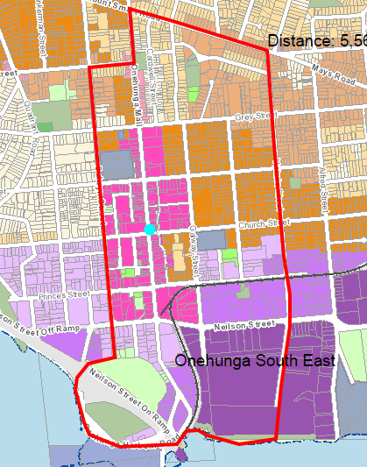

Balmoral – Potters Park

