Scholarship Geography Workshop One
Presented by AGTA and School of Environment, University of Auckland

Introduction to Scholarship Geography

Outcome Description
The student will use knowledge of geography to critically analyse a geographic context.

Scholarship Performance Descriptor
The student will demonstrate aspects of high level:
- analysis and critical thinking
- integration, synthesis, and application of highly developed knowledge, skills, and understanding to complex situations
- logical development, precision and clarity of ideas.

Outstanding Performance Descriptor
In addition to the requirements for Scholarship, the student will also demonstrate, in a sustained manner, aspects of:
- perception and insight
- sophisticated integration and abstraction
- independent reflection and extrapolation
- convincing communication.

In 2014, the examination questions and resource booklet will focus on urbanization, urban settlements, and urban growth.
Some resource materials (such as maps, text, photographs, models, graphs, tables and cartoons) related to this theme will be provided, to assist candidates within this geographic context.
Candidates will be required to complete questions that involve selecting, extracting, analysing, processing, predicting, justifying, and presenting information. Candidates will be required to include relevant original visuals that will enhance their answers.
Candidates will be expected to demonstrate understanding of a range of geographic perspectives and to use their geographic knowledge, skills, ideas, and understanding to support their answers.

Notes:

Notes

Lecture Notes: Mel Wall – The history of urban settlements, how they have grown over time and different types of settlements.

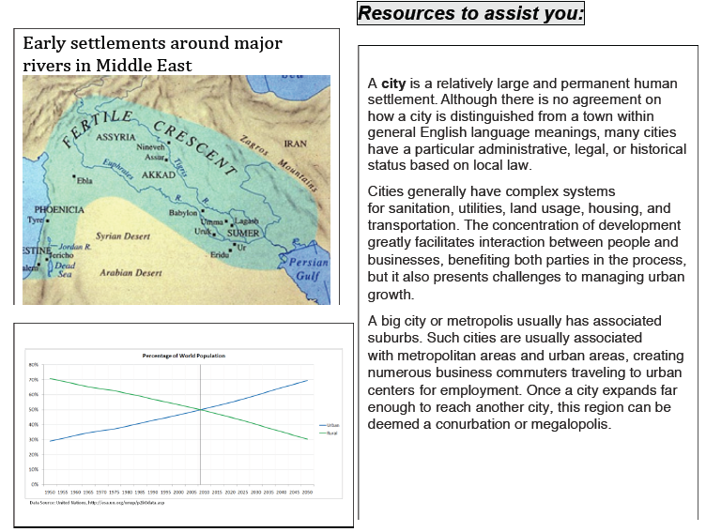

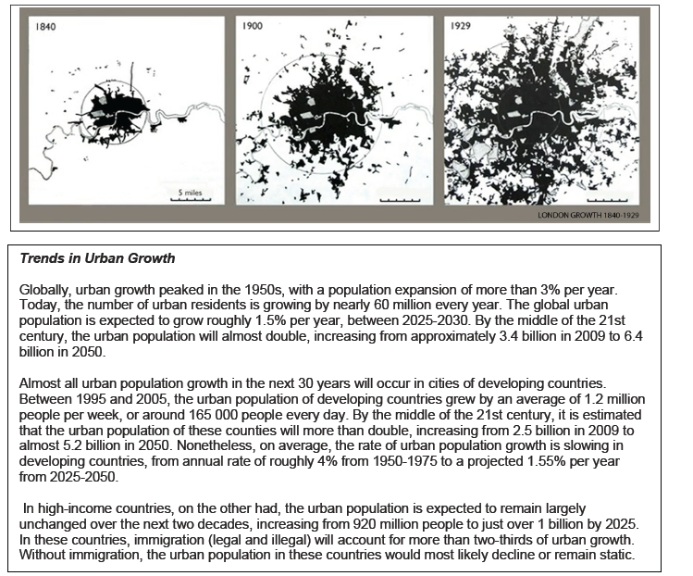

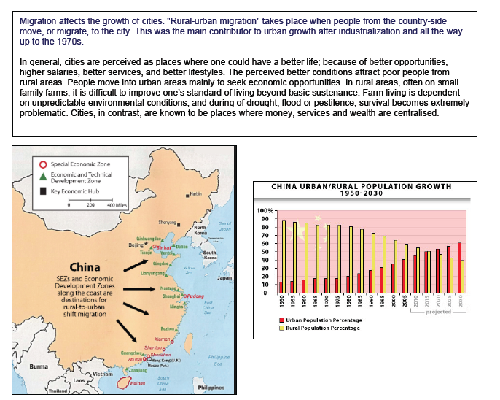
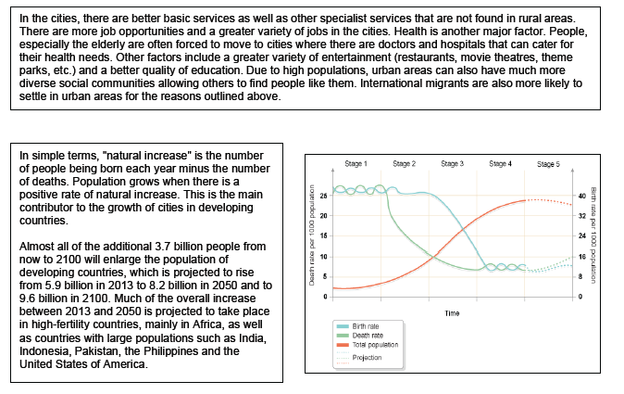

Tasks for students to complete:

Create a diagram to show the variety of factors that have contributed to the development of urban settlements.

Which is the most important factor that has contributed to the development of urban settlements? – come to a consensus in your group!

In your group, justify why you have chosen this factor as being the most important urban settlement. (this may mean you bullet point your ideas down).

