**Part A. Historical Context**

**Maori (AD1000)**Thought to have migrated from Asian countries, followed by Polynesia. Described in the legend of kupe in seven canoes from the ancient homeland called hawaiiki

**European settlers**

Tasman 1642; Cook 1769. For over 200 years the flow of Europeans has continued. Chinese and Indian migrants also joined the gold rush of the late 1800’s

**Polynesians (1960s onwards)**

Immigration of Polynesians encouraged. Many migrate for education, job opportunities, to be with family who have already migrated.

Asian Influx (1980’s until present)

Migration policy has favoured young, skilled migrants and investors. Source country is no longer an issue. Led to large increase in migrants from Asia affecting both ethnic diversity and age structure.

**Part B. Historical Trends – Northward Drift Post 1900**

1. **I**n 1900 MORE people lived on South Island than North Island!
2. During the 20th Century the population steadily moved north.
3. Today, in the 21st Century this movement north is not as important as it was. This is mainly because most people are in the north island already. Today 76% of NZ live in the North Island with 52% living in the northern third.
4. Today this trend continues but there is also growth in the South Island and some counter streams to places like Queenstown, Nelson and Canterbury.

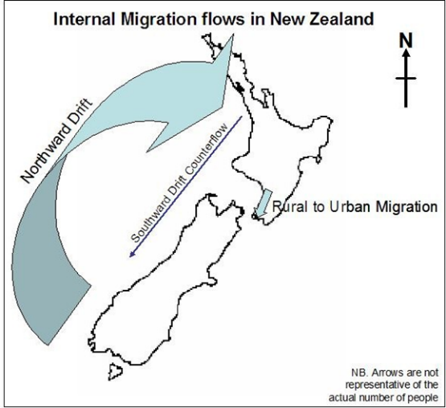



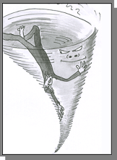**Part C. Current Issues and Challenges**

1. **Rural Depopulation**

The down turn in New Zealand rural

areas began in the 1980’s.

* The process of moving from rural to urban areas is known as **Urbanisation**.
* People usually move in a **stepwise fashion.**
* The process has **impacts** on both the rural and urban areas



New Zealand Herald: Rural exodus: Goodbye country ... small town NZ in decline as rush to cities grows

**“Once-thriving communities in New Zealand's heartland face a vicious circle of depopulation and economic hardship, as soaring rates and insufficient services force more people to cities in search of opportunity.**

Occasionally, someone comes in to Ame Khan's shop order his specialty, "the Bro Burger".Benneydale once had a butchery, a bakery and even a picture theatre but all are now empty shells. There were jobs in the town's coal mine until the early 90s and earlier at nearby Pureora in forestry, when native timber was milled in the area. But apart from the local meat works, a transport company and a smattering of farms there's not much going on - and even fewer people around.”

"It's dead as."

***Reasons****: interplay of pull of urban areas versus the push of rural areas, young people seeking greater opportunities, rural unemployment, desire for better service provision, lack of investment, remoteness*

***Impacts on Rural Areas****: ageing population, declining rural productivity, closure of schools and services, further outmigration, decline in rateable income*

1. **Auckl**a**nd: The Gateway City?**

New Zealand has experienced considerable

urban migration. Over 86% of New

Zealanders live in urban areas. Some of this

has been from internal migration with New

Zealanders moving to urban areas. Growth areas of the future with major urban centres are Auckland, Canterbury, Waikato and Bay of Plenty.

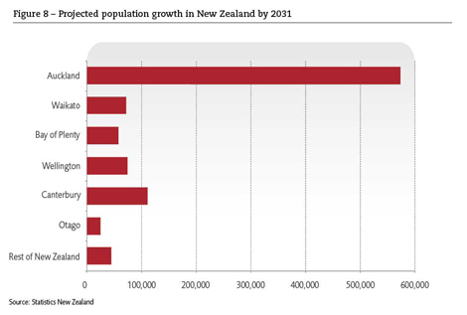

Considerable growth of urban areas since 1980 has been from immigration.

While European New Zealanders remain our largest ethnic group (more than 2.5 million), and Maori the second largest (more than 560 000 people), people from Asia, including India, have experienced the largest growth between 2001 and 2006 (from 238,176 to 354,552 people) Pasifika people showed the second-largest growth (from 226,376 to 265,974 people)

Auckland has the largest percentage of recent immigrants, with Asians making up 18.9% of the population and Pasifika people making up 14.4%

The number of people who say they are of mixed cultures has grown in New Zealand, from 9% in 2001 to 10.4%.

A **GATEWAY** city is the city where migrant tend to settle. Auckland is one of these with 53% of NZ’s migrants settled there. Much future growth of Auckland is expected to come from continued immigration. 65% of all Asian migrants have settled in Auckland and 67% of Pacific Migrants.

As natural increase continues to decline MIGRATION will play an ever important role in the future sustainability of New Zealand’s population.

# Auckland: Pacific power

**“As Auckland merges to create a supercity, the *Herald* looks back at how Auckland has changed over the years.**

About 67 per cent of 336,000 Pacific people are concentrated in Auckland, making up more than 14 per cent of the region's population. The next largest concentration (Wellington, with 13 per cent) is a long way behind.

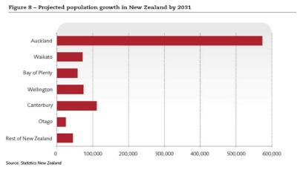Samoan is the second most spoken language after English in greater Auckland, Waitakere and, of course, Manukau, where Pacific Auckland is at its most visible.

About 28 per cent of that city's population is of Pacific origin. In Otara, the figure is an even more remarkable 79 per cent. Auckland, described in every touristy blurb as the biggest Polynesian city in the world, is also the de-facto capital for Cook Islanders, Niueans, Samoans and Tongans. There are more Cook Islanders and Niueans in Auckland than anywhere else in the world - including their home islands.

Anae, a first generation New Zealander and a product of that first Pacific settler community which grew up around the Newton PIC church, has argued that the browning of Auckland is more than just numbers, demographics and the negative social statistics that too often dominate the discourse about Pacific people. It is about influence, and the infiltration of a strong Pacific identity on Auckland's consciousness.

"Auckland is the Polynesian capital of the world and has become the showplace of Pacific culture, and the strong and vibrant Pacific identity in and around Auckland is there for all to see."



# Chinese, Indian arrivals swell immigration figures

New Zealand recorded its highest net migration gain last year and one in three permanent migrants now come from either China or India, new immigration figures show.

The Migration Trends and Outlook 2014/15, released today by Immigration New Zealand, shows a net migration gain of 58,300.

China was the largest permanent migrant source on 17 per cent, followed by India on 16 per cent. The United Kingdom, which used to be New Zealand's main source country, was third on 11 per cent.

India was the largest source country for skilled migrants (21 per cent) followed by the Philippines (13 per cent) and China was also the largest source country for family-sponsored migrants.

The spike in numbers as permanent arrivals, temporary workers and students has grown substantially in the past two to three years ."The interesting aspect is that the flows are very ethnically diverse ... and will have a major impact on the ethnic diversity of New Zealand."

1. **Intra- Urban Migration**

This is movement WITHIN, or INSIDE a city.

Where a person lives in a city depends on his or her income, age, workplace, lifestyle and family. As people’s circumstances change (they get a new job, lose a job, go to university, have children etc) they MOVE.

The average New Zealander shifts house at least once every five years. They may move towards the city or away from the city depending on life circumstances and preferences.

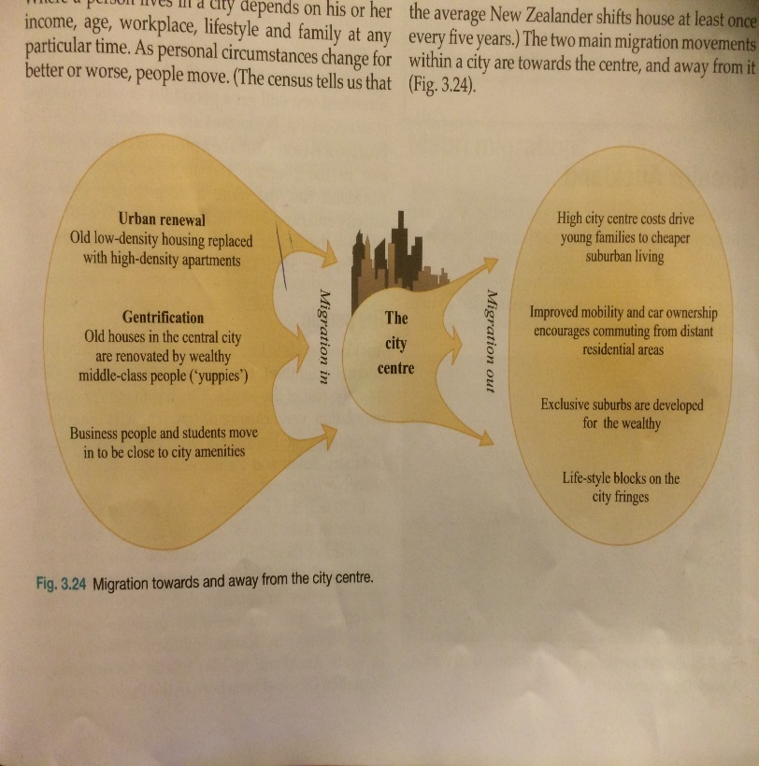

1. **Inter-Urban Migration**

This is movement BETWEEN cities.

Tauranga and Whakatane have been New Zealand's fastest growing towns over the past 80 years, as Kiwis followed the sun to the country's sunniest places.

A long-term analysis by economists from the Motu consulting group and Auckland University has found that sunshine hours were one of four main factors driving the growth and decline of 56 NZ towns from 1926 to 2006, along with the quality of the local agricultural land, local educational levels and proximity to the country's biggest city, Auckland.

Auckland itself was only the eighth-fastest-growing town over the 80 years, but it grew much faster than the three others of what were the four main centres in 1926 (Auckland, Wellington, Christchurch and Dunedin), so its faster growth helped to pull up other towns in the northern North Island.

All but one of the 10 fastest-growing towns were in the upper North Island. Levin, also a sunny spot just north of Wellington, was the sole exception.

1. **The Changing Face of the Brain Drain**

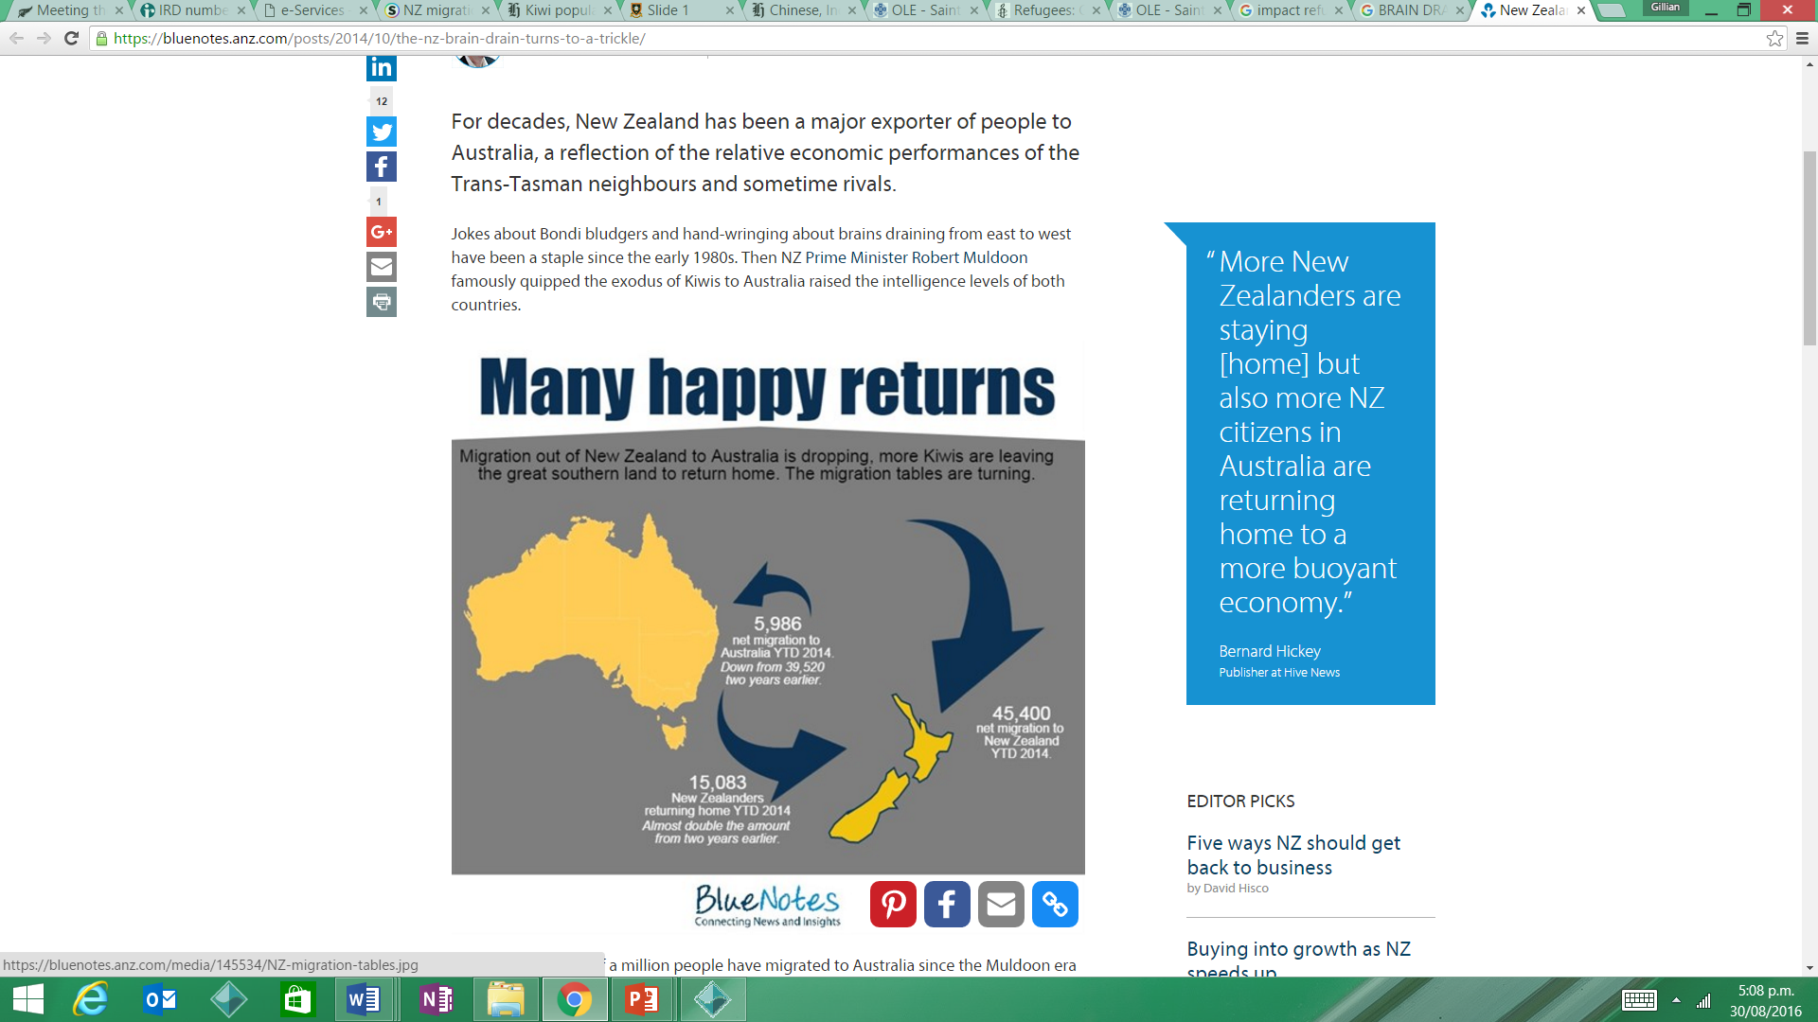

For decades, New Zealand has been a major exporter of people to Australia, a reflection of the relative economic performances of the Trans-Tasman neighbours and sometime rivals.

In net terms, over half a million people have migrated to Australia since the Muldoon era as Australia's wages galloped more than 30 per cent ahead of New Zealand's. Now that is changing - and in some surprising ways.

The[latest migration figures](https://anzlive.secure.force.com/servlet/servlet.FileDownload?file=00PD000000byUrTMAU) confirm record high net migration to New Zealand in the year to September of 45,400 or just over 1 per cent of the population. That's a massive turnaround from net outward migration of 3,280 just two years earlier.

The biggest contributor was a turnaround in the migration flows to Australia. Net migration to Australia dropped to 5,986 in the year to September from 39,520 two years earlier. In the month of September, just a net 68 New Zealanders left to live in the 'lucky' country, down from 2,488 in the same month two years earlier.

More New Zealanders are staying to help rebuild Christchurch and work on a building boom in Auckland but also more New Zealand citizens in Australia are returning home to a more buoyant economy.

The number of Kiwis returning home has almost doubled to 15,083 in the year to September from two years earlier, while the number of citizens leaving for Australia has almost halved over the same period to 25,122.

**Auckland’s Housing Crisis Creating a Brain Drain’ (NZ Herald, July 16) \***

Auckland's housing crisis is creating a brain drain as talented people move away from the city to escape the rising cost of living.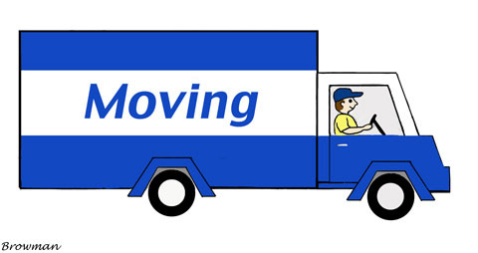

A recent survey which interviewed nearly 40,000 businesses in Auckland found many were struggling to attract talented employees. Three quarters said they had lost employees to other locations in New Zealand or overseas, nearly half of them to Christchurch or Tauranga.

"Many won't or can't come to Auckland as they know they won't be able to afford to live here, which impacts on skill levels within companies," said Frog Recruitment founder Jane Kennelly. “In addition, we are losing highly skilled Aucklanders to other regions in the country to pursue a better work-life balance.

"With the median house price in Auckland currently 10 times the median income, possibly reaching nearly $2 million by 2020, it's fair to say we have a problem on our hands that is only going to get worse."

The survey also found that with more employees renting rather than owning a home in Auckland, people were often needing extra time off for sick and moving days. People renting were often unable to move into better quality housing and many had to move around frequently as rents continued to rise, the survey found.

Auckland's traffic problems also came under fire in the survey's responses. Frustrated employees arrive at work stressed from the traffic, and those using public transport were often late to work.

Some companies had introduced policies to help with the housing issues including late/flexible start times, working from home, commuting allowances and free car parks. Just over 10 per cent had been approached by staff asking for pay rises to combat the high cost of living.

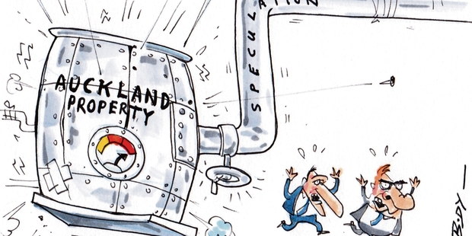

1. **Refugee Migration**

A refugee is someone who has been forced to flee his or her country because of persecution, war, or violence. A refugee has a well-founded fear of persecution for reasons of race, religion, nationality, political opinion or membership in a particular social group. Most likely, they cannot return home or are afraid to do so. War and ethnic, tribal and religious violence are leading causes of refugees fleeing their countries.

If you’re identified as a refugee by the United Nations High Commission for Refugees (UNHCR) and selected for resettlement in New Zealand you’ll stay at the Mangere Refugee Resettlement Centre for 6 weeks before being settled into a community.

Recently, in response to the growing refugee crisis in Syria the New Zealand Government raised the annual quota of refugees into New Zealand from 750 to 1000 per annum.

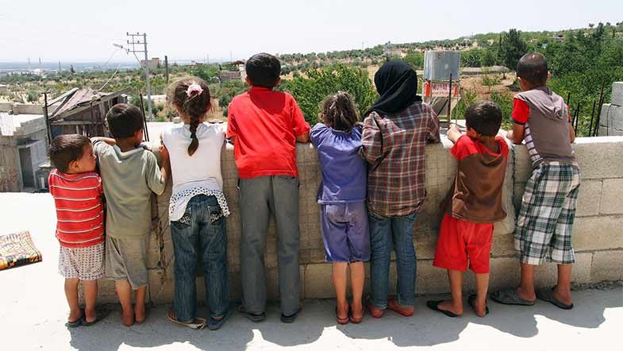

Refreshing as the New Zealand ‘just get on with it’ approach to refugee resettlement is, it hides some important issues that we’d do well to think and talk about. *Grant Bayldon, Executive Director at Amnesty International New Zealand*

On the international stage we’re really not doing our bit – in fact our annual intake of refugees is tiny by world standards, even for our size. For all Australia’s faults on this issue, they take five times as many refugees as New Zealand on a per capita basis.

Many mistakenly believe refugees come here for economic reasons, or that if refugees were genuine they’d simply stay in the neighbouring countries they often have to pass through to get here.

To stay in a country that doesn’t recognise your rights as a refugee means to remain an illegal immigrant indefinitely. You couldn’t legally work, your children couldn’t go to school, and you would remain at risk of arrest, detention and deportation for the rest of your life.

There’s a strong case to help the world’s most vulnerable people, simply out of a sense of humanity – to offer the sort of hand up we’d want if the roles were reversed. But what of the other side, the benefits to New Zealand? Is it just an act of charity or does it really stack up for us as a country?

New Zealand prides itself on punching above its weight on the world stage; this is how the Government pitched for a seat on the United Nations Security Council. But without pulling our weight in areas like refugee resettlement, peacekeeping and development, our international profile starts to just look like trade, trade, trade – a kind of cynical ‘Fonterra Foreign Policy’. Doing our share to resettle refugees is an important part of our international responsibility and credibility.

As you’d expect, the early years are often difficult for new refugees, so work rates start out lower, but converge toward the national average with time in the country. It’s the second generation where things really start to take off, with work rates higher than the national average.

The study concludes that there are significant economic benefits to the country, with refugees more likely to start businesses and to move to rural areas experiencing labour shortages.

But while the positive spin-offs for New Zealand are a bonus, they’re not really the point. The Refugee Convention recognised a basic human right: to seek protection if we are forced to flee our country. If we believe that this should be a fundamental right for all – one we would wish for ourselves if it were ever needed – then New Zealand needs to play its part in providing this protection.

**Part D: Maori Concepts**

**Tikanga Maori** : The movement of small numbers of Maori people back to iwi (tribal) areas, from cities is occurring following a long period of urbanisation. During the 1990s there was a renaissance (re-birth) of Maori values and a growing awareness of the importance of **Tikanga Maori** (Maori culture). As a result small numbers of young urban Maori are returning to tribal areas, e.g. in Hokianga.

**Whakapapa:** is defined as being geneology. This could also relate to urban to rural migration because urban Maori often migrate back to their tribal lands to learn and be a part of their cultural customs and traditions.



**Part E: Discussion Questions**

Q1. Gain or Drain? Discuss the Refugee question in relation to NZ.

Q2. Auckland’s dominance as a migrant Gateway City threatens the viability of NZ’s regions.

Q3. Rural rejuvenation will never reverse the ongoing trend of rural depopulation in NZ.

Q4. Intra-urban migration is the dominant movement of people shaping the geography of NZ cities today.