INTERPRETING CENSUS DATA

INSTRUCTIONS

You need to know what statistical area unit you are looking for.

Not all statistical area units have commonly known suburb names so you will have to find the nearest match.

Western Park is located in the suburb of _____________________________________________

STATISTICS

- Statistics NZ website : http://goo.gl/6BR57e (shortened url)

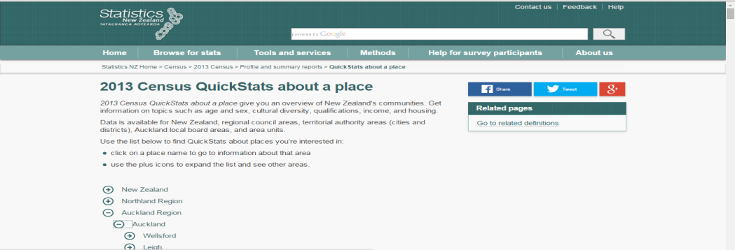

- To find Freemans Bay from this list, use the keyboard command: Ctrl + F
- This will bring up the FIND tab where you will be able to enter Freemans Bay.

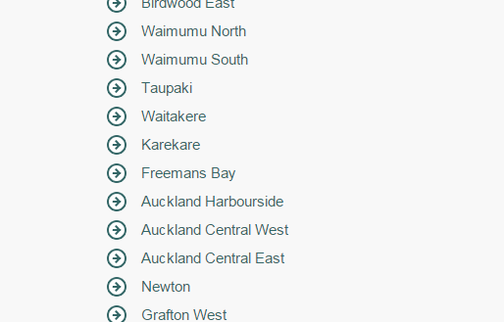

- Click this link and it will take you to an information page.

- One the “Freemans Bay” QuickStats page, click on View as PDF on the right of the page under Links
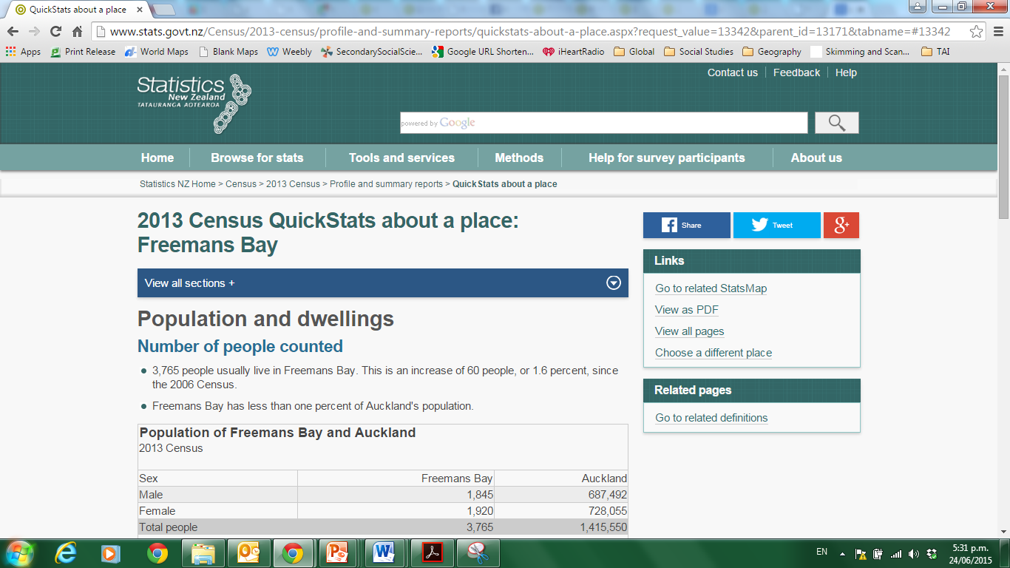

Download the PDF onto your student drive.

LANDUSE MAPS

- Open a tab for Statistics NZ Geographic Boundary site - http://goo.gl/lKzvoE
- Open a tab for the Auckland Unitary Plan site - https://goo.gl/2hLJaf

- In Statistics NZ Geographic Boundary site:
- Locate Freemans Bay

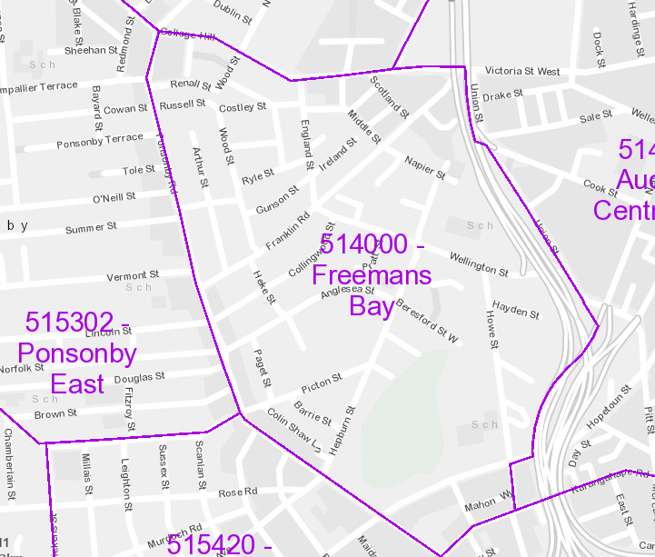

- In the Auckland Unitary Plan page, search for Freemans Bay in the search tab and press enter
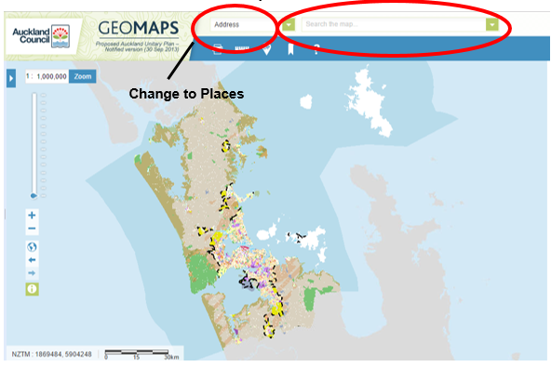

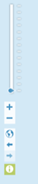

- Use the Zoom controls on the left of the screen to zoom out to see all of Freemans Bay

- Use the Geographic Statistical map you created previously to ensure you are looking at the same area on both maps
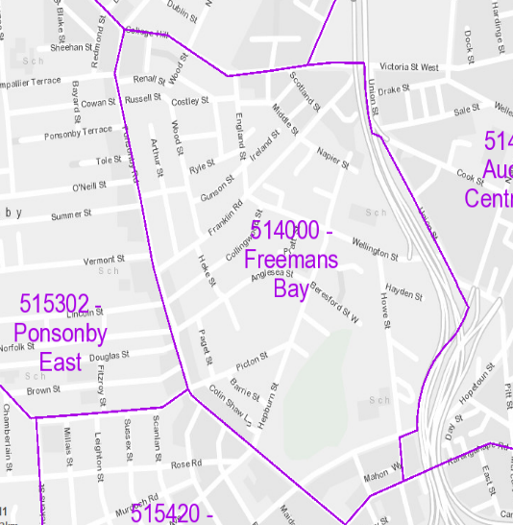

- Using the drawing tool

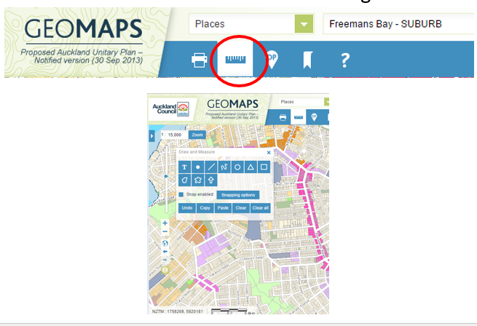
This tool will enable you to draw around an area
This tool will enable you to write text on the map

- Completed Landuse map
12. Click the side arrow to extend the side box.
Click the Legend Tab and then “view the full legend” and this will give you a key for the land use

- You will need to complete this same exercise for the two parks we will visit on the field trip:
- Barry Curtis Park – Ormiston
- Potters Park – Balmoral
- Jordan Park – Onehunga South East

